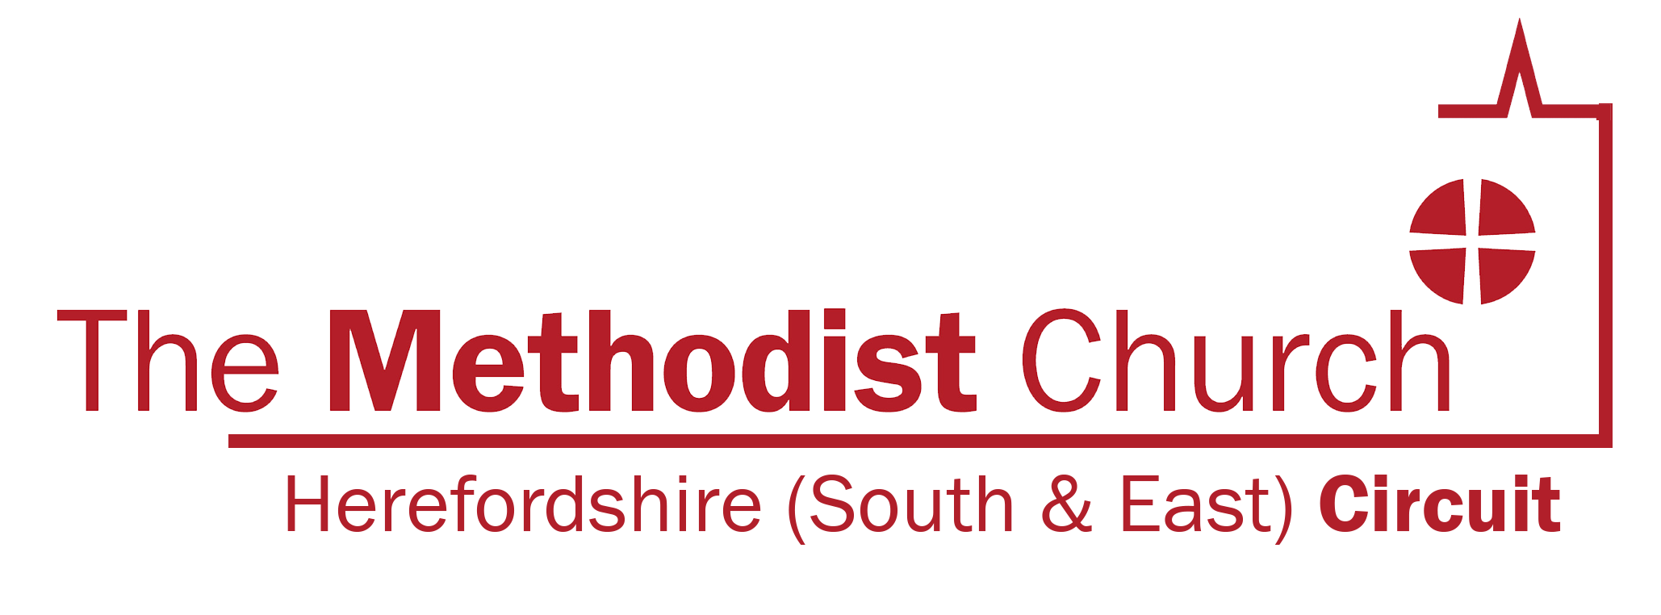
Birmingham (West) & Oldbury Circuit

3rd December 2020

RE: Circuit guidance on the re-opening of Churches

Dear Church Stewards,

Greeting to you all in the precious name of our Lord and Saviour Jesus Christ!

I am writing this letter to you all for further information and clarity following the government’s announcement of lifting the second Lockdown which expired yesterday 2nd December 2020. Covid-19 guidance for the safe use of places of worship from 2nd December was clear that places of worship may re-open. However, in areas subject to Tier 3 which we happen to be in, there are restrictions that must be followed. We must not meet with people outside of our household or support bubble in a private garden or in most outdoor public venues. People must not mingle indoors with anyone they do not live with or have formed a support bubble with. The number of people must be limited within a place of worship. There must be no socialising within or outside the church (e.g. on carparks) before or after services of worship due to the potential for increased spread of Covid-19.

With these government guidelines, the Circuit Leadership has agreed to support all churches that wish to re-open with information and guidance that great caution has to be excised by managing trustees. For those who decide to delay re-opening, we will offer support through pastoral letters; worship service sheets will be distributed to you through our circuit administrator. Prayer support and the options of using virtual worship services will be encouraged for those who can manage to do this online. Your pastoral leaders will also continue to send you devotional messages, as well as Christmas cards at this festival season.

There must be no pressure on anyone to do what they feel is too risky for them. From ministers, lay leaders, local preachers, church stewards no one should be put at risk at all in this pandemic disease we are experiencing. For those who are in the 70+ age prolife, please consider your own safety as well as that of others. Brothers and sisters let me emphasises this point that we do not put ourselves into temptation; no-one knows another person’s underlining condition, so let us not put pressure on those who cannot make it under Tier 3 to go to a place of worship. We know our situations better than anyone else. Therefore, wash your hands regularly, wear a face mask, maintain social distance all the time: the vaccine is on its way, let us be patient; we will get out of this miserable situation in which we find ourselves.

Remember, places of worship play an important role in providing spiritual leadership for many people, and in bringing communities and generations together. However, their communal nature also makes them places that are vulnerable to the spread of coronavirus (Covid-19). Let us continue to keep an eye on changes that may happen in the level of our tiers. Please revise immediately if things (tiers) change. The Church Council has the final decision for the life of your church.

You are always in my prayers, day and night. May the good Lord protect you and keep you safe. Pray for one another. Christmas this year will go down in history.

Happy Christmas to you all!

Yours in Christ

Mucha
MUCHARUTYA CHISVO
SUPERINTENDENT MINISTER
Mucharutya.chisvo@methodist

